**Zn foil**

14-05-2020 – Dmitry/..

PETRA III Extension Beamline P65

XAS CONTINUOUS MODE

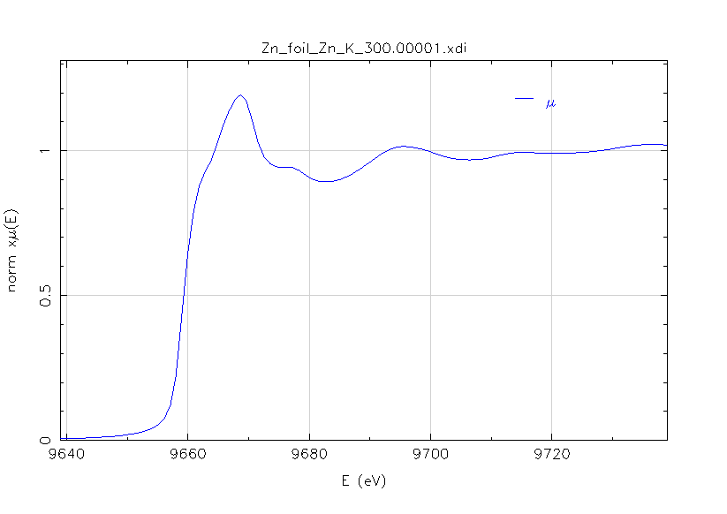

E0 = **9659** eV, Edge step = **1.9**, Pre-edge = -150 to -30 eV, Normalization = 50 to 750 eV

kw = 2

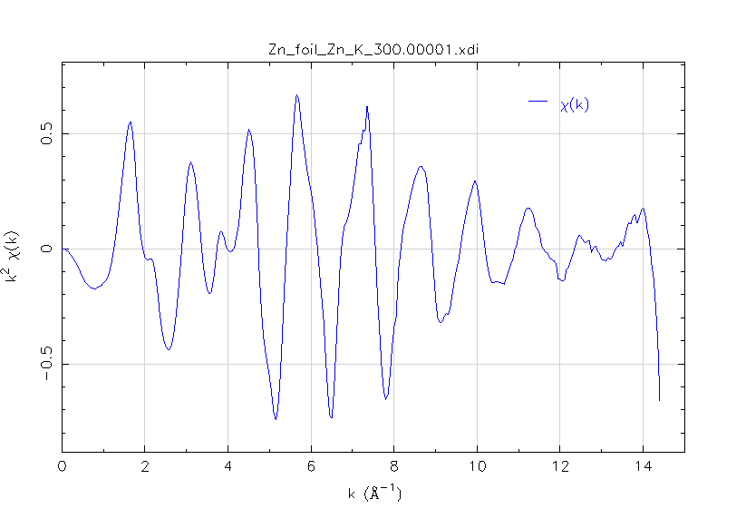

FT k range = 2.9 – 12.9 Å-1

